Project Design Phase-II
Data Flow Diagram & User Stories
Date | 1 October 2026
Team ID | SWTID-2026-2051
Project Name | Script-Controlled ACL – Restrict Record Access Based on Field Value (ServiceNow)
Maximum Marks | 4 Marks

Data Flow Diagrams:
A Data Flow Diagram (DFD) is a visual representation of the information flows within a system. It shows how data enters and leaves the system, what changes the information, and where data is stored.
For this project the system is the ServiceNow instance that protects the Institution Details table (u_institution_details). Every request from a user passes through role resolution and ACL evaluation before any record is read, created, edited or deleted.

Data flow description
Flow | Source | Destination | Data carried
F1 | Administrator / EEE Branch User / User without role | 1.0 Authenticate & resolve roles | Login credentials entered on the ServiceNow instance
F2 | 1.0 Authenticate & resolve roles | D1 Users & Roles | User record and assigned roles (admin, bb1, bb2, bb3, bb4) are looked up
F3 | 1.0 Authenticate & resolve roles | 2.0 Evaluate ACL | Authenticated user together with the resolved role set
F4 | 2.0 Evaluate ACL | D2 ACL Rules | Read / Create / Write / Delete ACLs on u_institution_details are fetched; Requires-role, data condition (Branch is EEE) and ACL script are evaluated
F5 | 2.0 Evaluate ACL | 3.0 Process record request | Allow / deny decision for the requested operation
F6 | 3.0 Process record request | D3 Institution Details | Records are read, created, updated or deleted only when the decision is allow
F7 | 3.0 Process record request | Administrator | All records regardless of branch (admin override)
F8 | 3.0 Process record request | EEE Branch User | Only EEE branch records; New button, inline edit and Delete appear according to roles bb2, bb3 and bb4
F9 | 3.0 Process record request | User without role | Empty list – "No records to display"

DFD Level 0
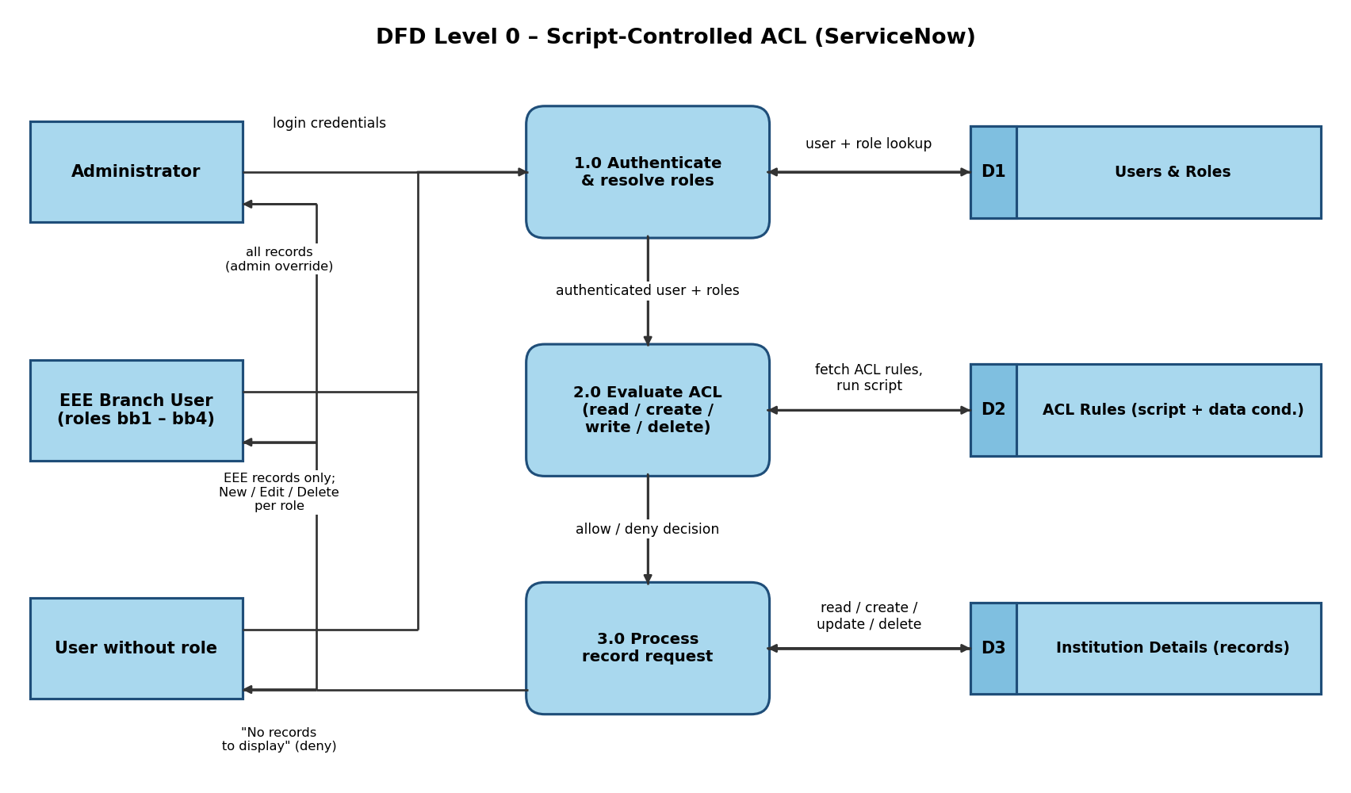

User Stories
List of user stories for the product, grouped by functional requirement (epic).
User Type | Functional Requirement (Epic) | User Story Number | User Story / Task | Acceptance criteria | Priority | Release
Administrator | User & Role Setup | USN-1 | As an administrator, I can create the EEE User and the custom roles bb1, bb2, bb3 and bb4 and assign them to the user. | User and roles exist; all four roles are listed against EEE User | High | Sprint-1
Administrator | Table Setup | USN-2 | As an administrator, I can create the Institution Details table (u_institution_details) with Student Roll Number, Student Name, Faculty Name, Branch, Email, Phone Number and Description fields. | Table is saved and all seven fields appear in the table columns | High | Sprint-1
Administrator | Table Setup | USN-3 | As an administrator, I can add sample records with different Branch values (ECE, EEE, CSE). | List shows records for all three branches | Medium | Sprint-1
Administrator | Read ACL | USN-4 | As an administrator, I can create a script-controlled read ACL on u_institution_details that requires role bb1 and a data condition of Branch is EEE. | ACL is active, Advanced is ticked, bb1 is in Requires role and the script is saved | High | Sprint-2
Administrator | Read ACL | USN-5 | As an administrator, I can view all records regardless of branch. | On impersonating Admin, every record (ECE, EEE, CSE) is listed | High | Sprint-2
EEE Branch User (bb1) | Read ACL | USN-6 | As an EEE branch user with role bb1, I can view only the EEE branch records. | List shows only records where Branch is EEE | High | Sprint-2
User without role | Read ACL | USN-7 | As a user without the required role, I am prevented from viewing any records. | List shows "No records to display" | High | Sprint-2
Administrator | Create ACL | USN-8 | As an administrator, I can create a create ACL on u_institution_details that requires role bb2. | ACL is active with bb2 in Requires role and no data condition | Medium | Sprint-3
Record Creator (bb1 + bb2) | Create ACL | USN-9 | As a user with roles bb1 and bb2, I can see the EEE records and the New button to create a record. | EEE records are listed and the New button is visible | Medium | Sprint-3
Administrator | Write ACL | USN-10 | As an administrator, I can create a write ACL on u_institution_details that requires role bb3. | ACL is active with bb3 in Requires role and no data condition | Medium | Sprint-3
Record Editor (bb1 + bb2 + bb3) | Write ACL | USN-11 | As a user with roles bb1, bb2 and bb3, I can edit EEE branch records (for example, the Description field) from the list. | Inline edit saves the change, e.g. Description shows "ACL Is Executed" | Medium | Sprint-3
Administrator | Delete ACL | USN-12 | As an administrator, I can create a delete ACL on u_institution_details that requires role bb4. | ACL is active with bb4 in Requires role and no data condition | Medium | Sprint-4
Record Manager (bb1 – bb4) | Delete ACL | USN-13 | As a user with roles bb1, bb2, bb3 and bb4, I can view, create, edit and delete EEE branch records. | Selected EEE record is removed after Delete is confirmed | Medium | Sprint-4
Administrator | Verification | USN-14 | As an administrator, I can impersonate the EEE user, a user without roles and the admin to verify every ACL. | Each impersonated user sees exactly the access described in USN-5 to USN-13 | High | Sprint-4

